**Capstone Project**

**Service flow:**

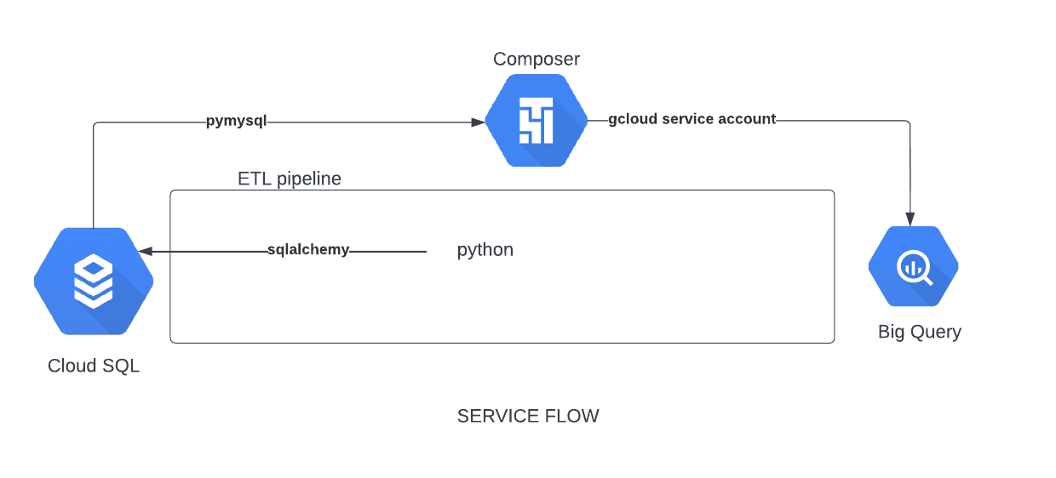

**Service flow Brief:**

1. Created a cloud SQL instance.
2. Initially tables were created based on the OLTP schema on the My SQL instance of Cloud SQL.(we took care of repeatable scripts to create tables again and again in both OLTP and Star schemas)
3. The fake data was created using faker library and ingested into the OLTP tables using SQL Alchemy library by creating engine.
4. Create tables in Big Query using the Star schema
5. The data in OLTP tables could be transformed and loaded into the Big Query tables using gcloud service account with required Big Query permissions.
6. Write a script for DAG Composer to create ETL pipe line.
7. Generate new 5000 records and populate in OLTP tables.
8. The composer would be run to do incremental ETL of the new records.
9. Using the tables in Big Query, the required analytics can be retrieved by querying.